Jira user management for particular project

For particular user or group to access the project give the following permissions to user or group created.

Initially created one project named “Sample” in Jira

Click on isssues

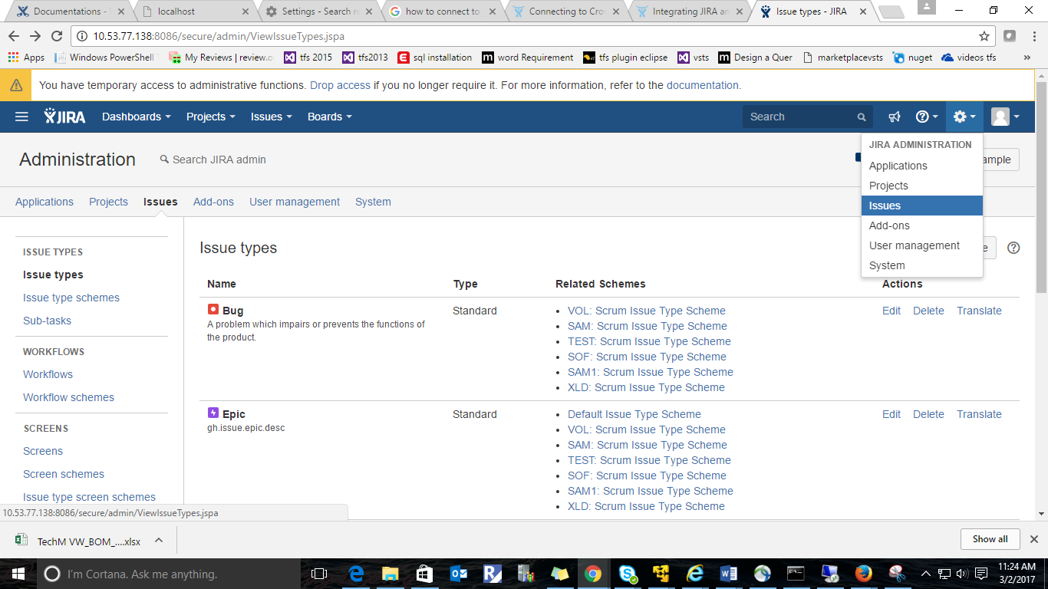

Go to Permission schemes

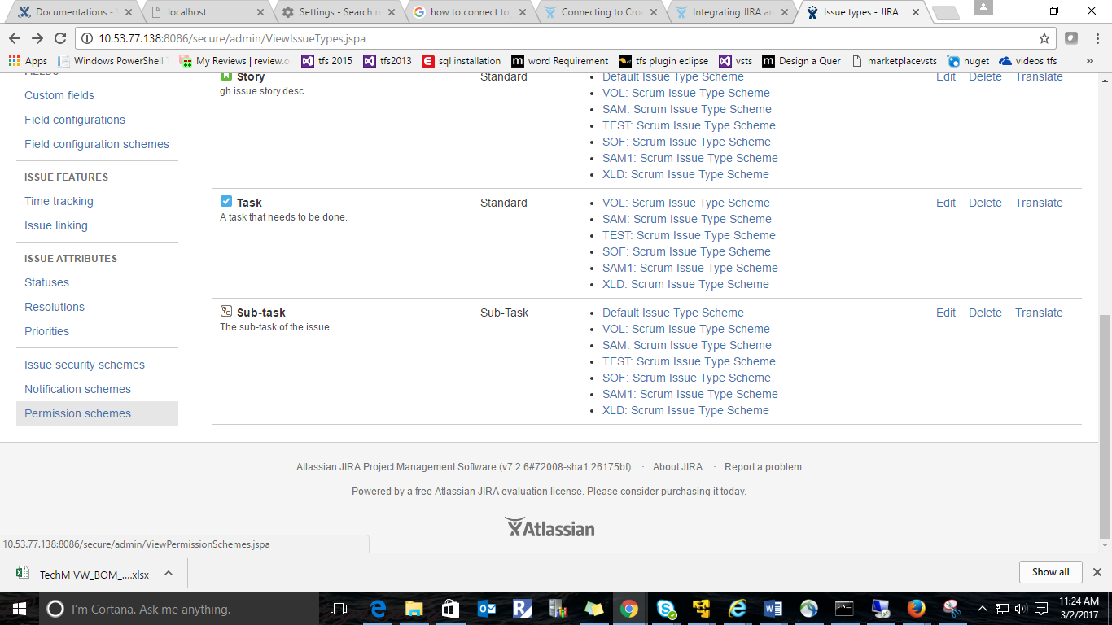

Created one Permission Schema namely “Sample Permission Scheme” and assigned to project “Sample”

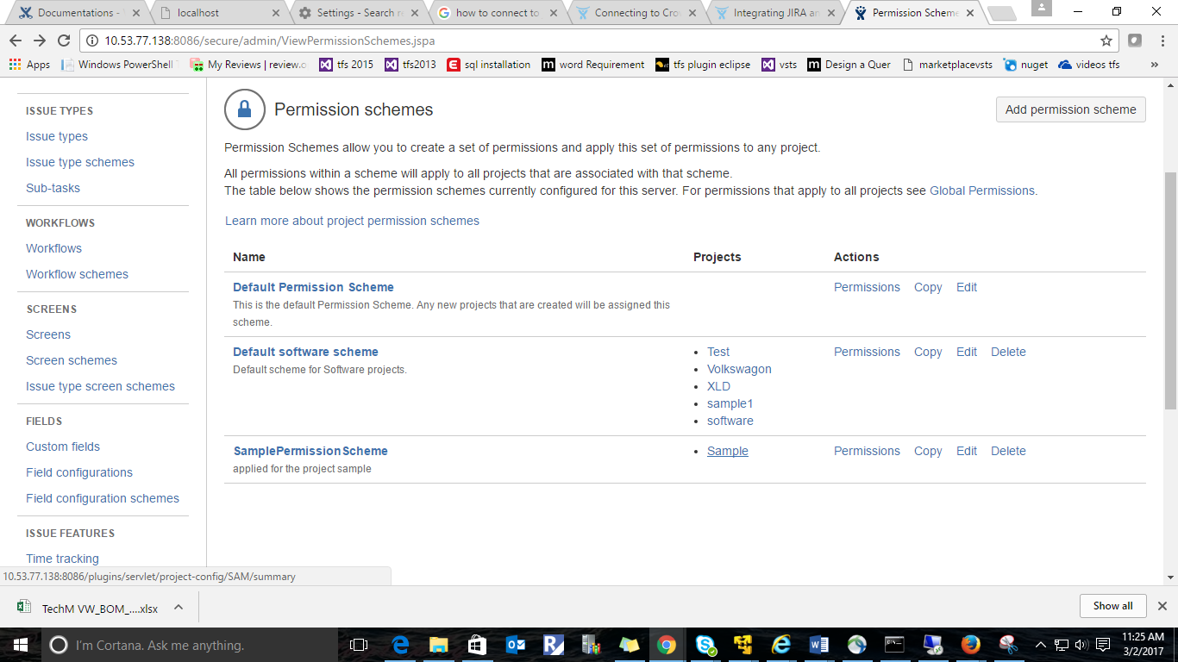

Click on “Sample” Project and go to Permissions

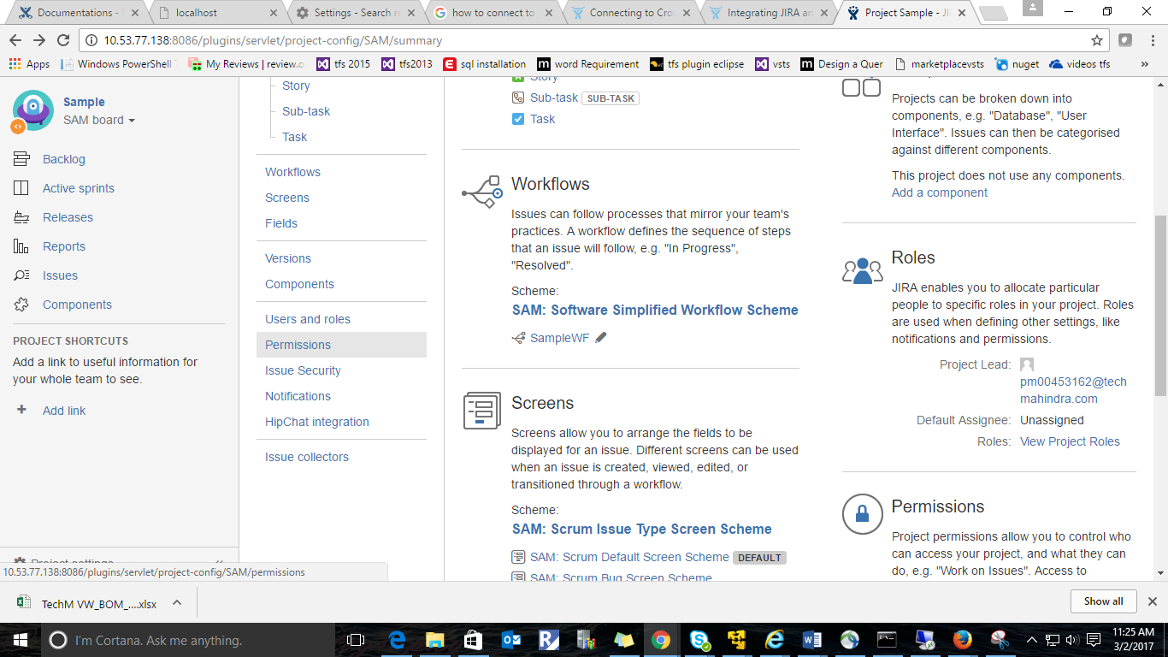

Go to Actions and click on “Edit permissions”

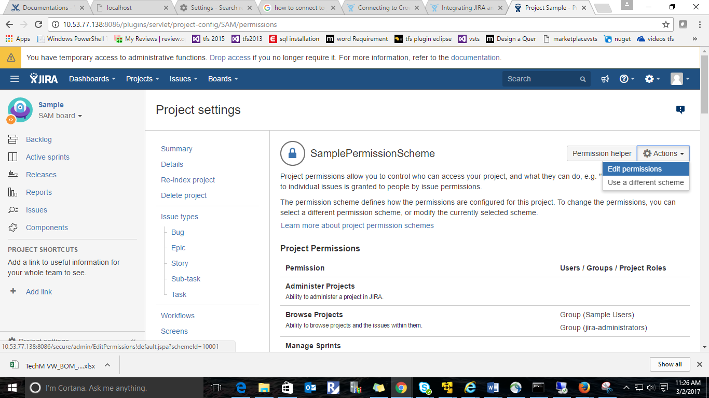

In Project Permissions Under “Browse Projects” Grant Permissions to the user or group who can access this “sample” project.

